How to generate GlobalSight web service client invoking codes

Steps:

<1> Create a java project in eclipse.
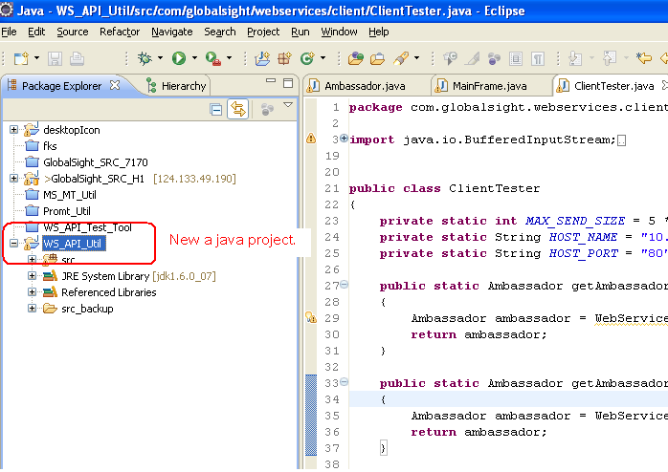

<2> Create web service client invoking codes for GlobalSight.

- “File” >> “New” >> “Other”.
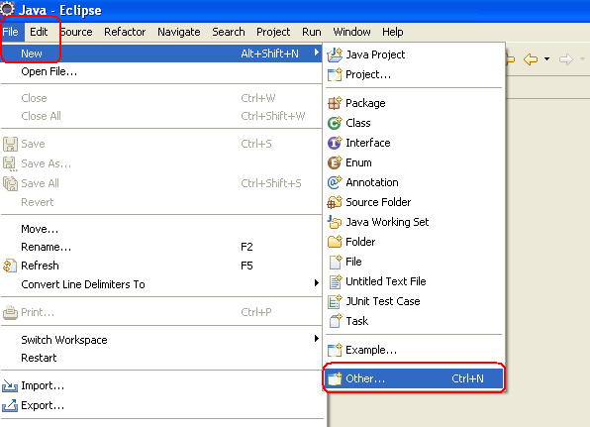

- Select “Web Services” >> “Web Service Client”, then “Next”.
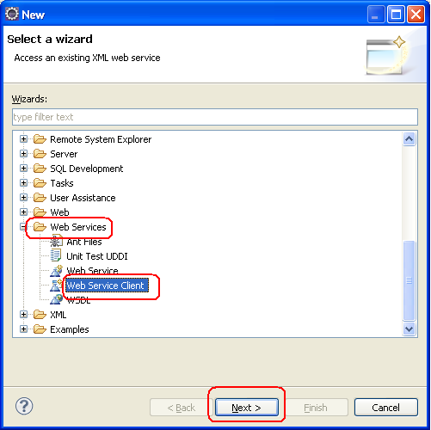

- In “service definition”, input url:
http://<host_name_or_IP>:<port>/globalsight/services/AmbassadorWebService?wsdl
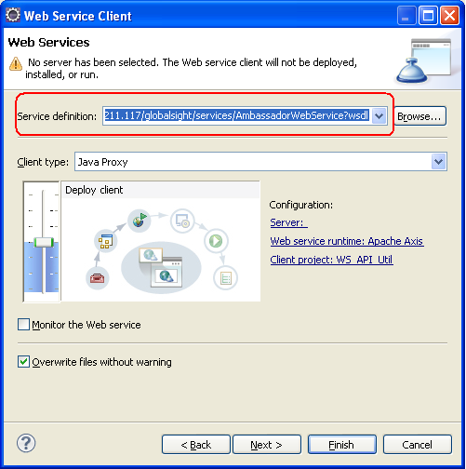

If the url server is in running, eclipse will check if this is a valid service definition. If it is valid, “finish” button will be enabled.

- Click “finish”, then eclipse will generate client invoking codes.
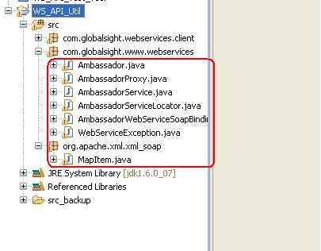

<3> how to use these codes?

- Write a helper class to get a proxy interface. (The sample codes will be delivered together)

- Write a tester class to test all APIs.

<4> Notes: These codes can be used in web service test tool, desktop icon, and any client tools that need invoke APIs of GlobalSight.

